

CS152

Human Computer Interaction

NeuroPal

(Mental Health Tracker)

[Part 3.1]

A Project Proposal By:

Void

Dela Serna, Adrianne Faye

Javines, Kienth Justine

Dolorito, J-mar

June 4, 2024

1. **Project Description**

NeuroPal is a comprehensive mental health application designed by Team Void to provide users with a range of tools and resources to manage their mental well-being. The app addresses the increasing demands of modern life by offering features such as mood tracking, journaling, mindfulness exercises, and community support, all within a single, unified platform. NeuroPal is designed with accessibility and user-centric principles in mind, ensuring that individuals from diverse backgrounds can benefit from its offerings. The app aims to create a secure, supportive space where users can express their feelings, set personal goals, and access professional help when needed. By integrating multiple mental health support features, NeuroPal seeks to enhance the overall well-being of its users.

1. **Requirements Summary**

User Interface and Navigation: The system must have an intuitive interface that is easy to navigate, ensuring users can effortlessly access various features such as mood tracking, journaling, and mindfulness exercises.

**Mood Tracking:** Daily mood logging with options to describe feelings and add context. Visual mood charts track patterns and trends over time.

**Journaling**: A secure space where users can write about their experiences and ideas, with customized exercises to guide their reflections.

**Mindfulness Exercises:** Guided meditations and breathing exercises designed to reduce stress and promote mental clarity.

**Mood and Activity Log:** Logging activities and correlating them with mood entries to help users identify triggers and patterns.

**Void (For Ranting and Anger Management):** A dedicated space for users to vent their frustrations and manage anger healthily.

**Time Capsule:** A feature allowing users to write messages to their future selves with delivery dates, promoting self-reflection and long-term goal setting.

**Goal Setting and Progress Tracking:** Tools for setting and tracking academic and personal goals, with visual progress indicators.

**Community Support Group:** Forums and groups where users can share experiences, offer support, and receive encouragement from peers.

**Crisis Support and Resources:** Easy access to emergency contacts and crisis support services, providing immediate help when needed.

**Therapist Directory and Teletherapy:** A directory of licensed therapists with options for booking teletherapy sessions for professional mental health support.

**Educational Resources:** A collection of articles, videos, and resources on mental health topics relevant to users' needs, enhancing their knowledge and coping strategies.

**Accessibility and Compatibility:** The app should be accessible across iOS and Android devices, ensuring broad usability.

1. **Prototype Description**

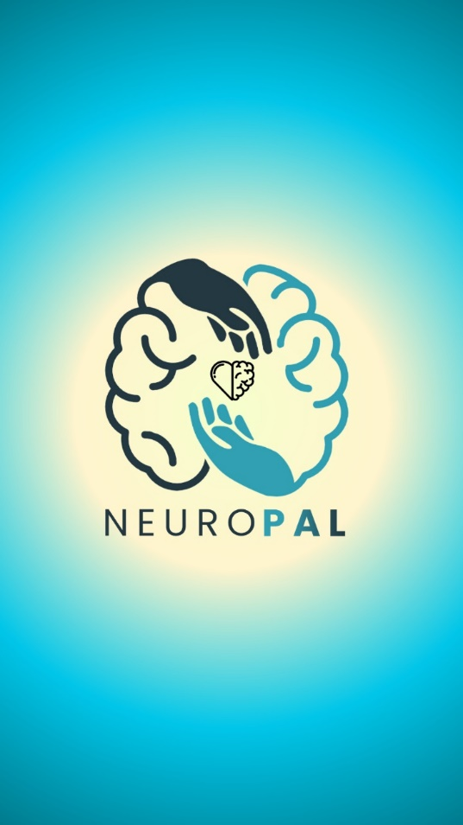

**Loading Page**

The initial screen users encounter when opening the app. This page is displayed while the app completes its loading process.

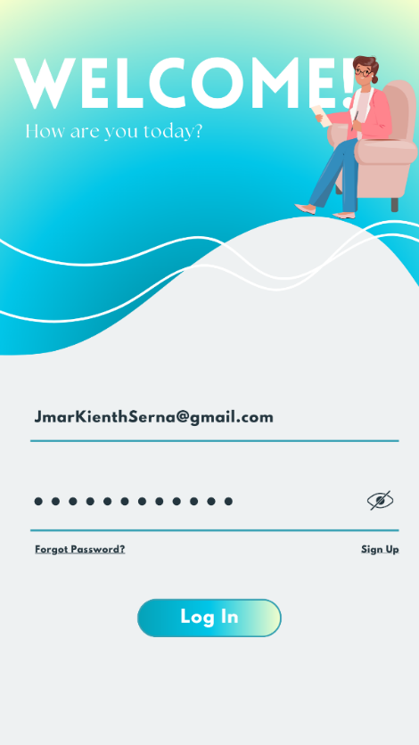

**Log In and Sign-Up page**

This page allows users to input their account details to securely log in and access their personalized dashboard. New users can easily sign up by providing their information, ensuring a seamless and efficient onboarding process. Sign in or create an account to unlock all the features and benefits our platform has to offer.

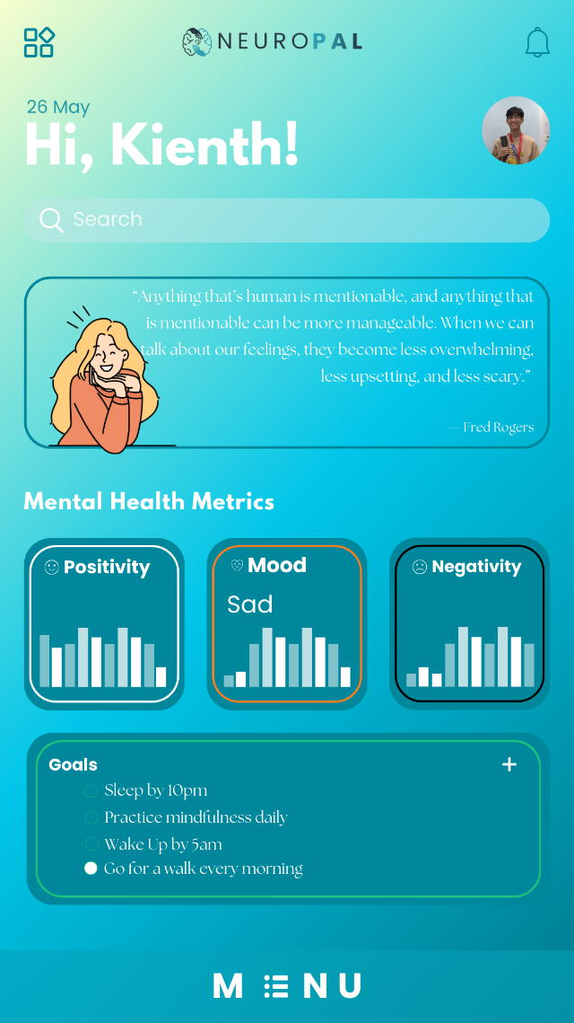

**Main Page**

The main page provides a comprehensive view of your mental health metrics, including graphs that track positivity, mood, and negativity based on this month's records. You can set and monitor your personal goals, receive daily mental health quotes for inspiration, and utilize the search bar to quickly find specific features within the app. Stay informed and motivated with easy access to all your mental wellness tools in one place.

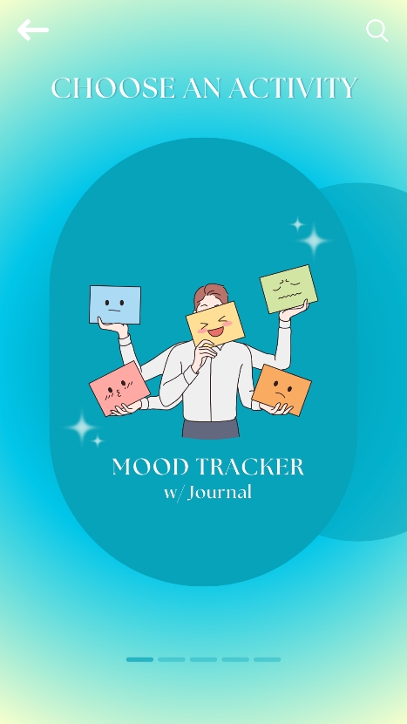 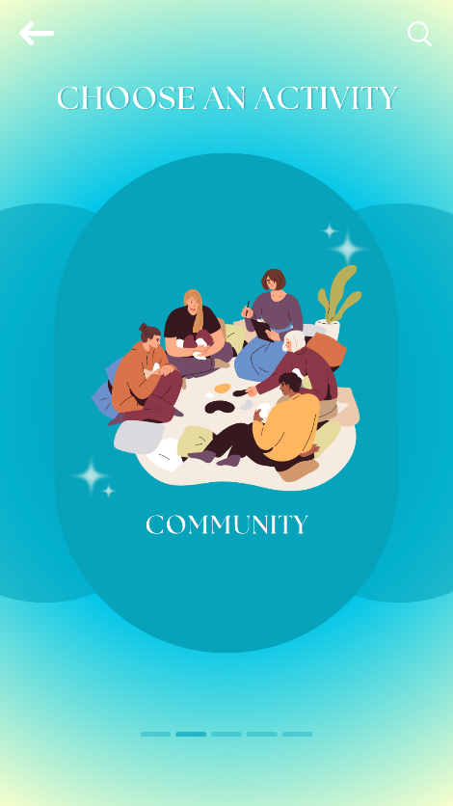 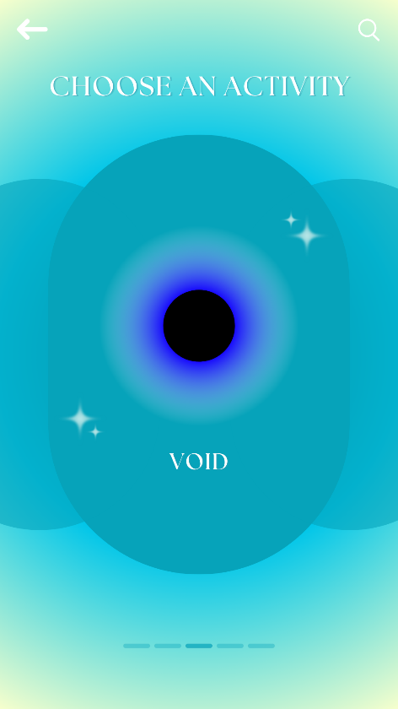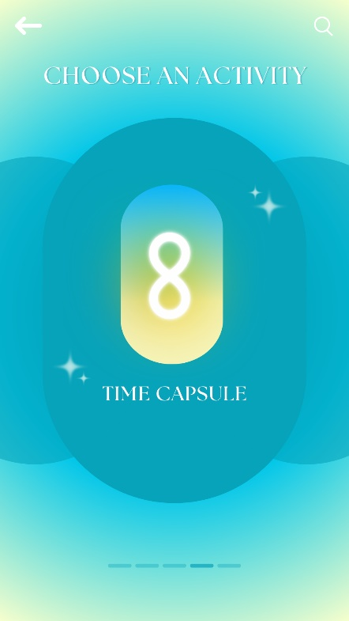 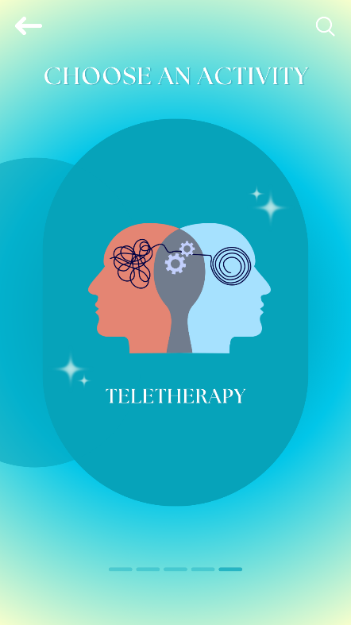

**Menu Page**

This menu page features a vibrant and intuitive design that invites users to choose an activity tailored to their mental health needs. The background gradient transitions smoothly from a calming light yellow to a serene blue, creating a soothing visual experience. At the center, an engaging illustration depicts a character holding various mood icons, emphasizing the mood tracker with a journal. The clean typography and easily recognizable icons ensure that users can navigate the menu effortlessly. Additional activities like community engagement, the void for personal reflections, time capsule, and teletherapy can be accessed via the search bar or by swiping through the options, making it simple and enjoyable to find and select the desired feature.

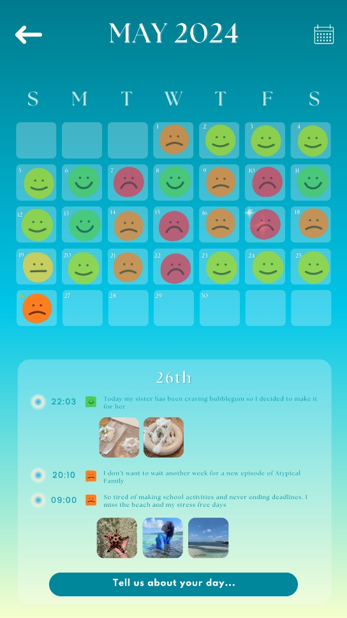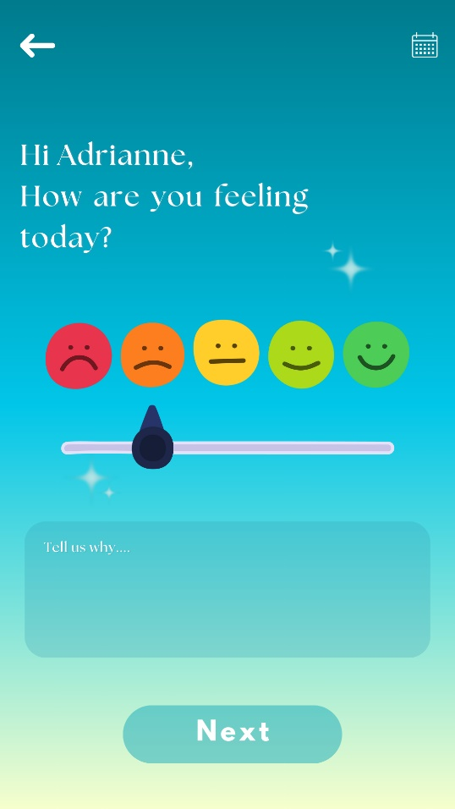

**Mood Tracker**

The mood tracker activity offers a user-friendly interface for tracking daily moods and journaling experiences. Upon opening, users are greeted with a question about their current feelings, which they can express through an intuitive slider featuring a range of emoticons. Below the slider, a text box invites users to share more details about their day. The calendar view on the second screen provides an at-a-glance overview of mood patterns over the month, with each day marked by a corresponding emoticon. Users can click on specific dates to see detailed entries, promoting self-reflection and emotional awareness.

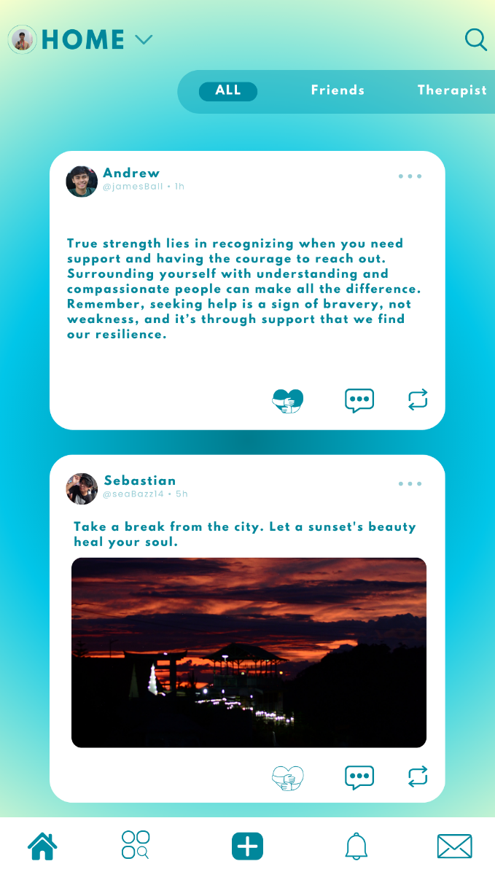< - **Community** The community page serves as the app's social feed, allowing users to connect and engage with posts from friends, therapists, and the broader community. The feed displays supportive messages and inspiring quotes, encouraging mental well-being and resilience. Users can easily switch between viewing all posts, posts from friends, or posts from their therapist. Interactive buttons allow for liking, commenting, and sharing posts, fostering a sense of community and mutual support within the app.

 **<- Void -**This page offers a unique emotional release feature called "Scream into the Void," where users can express their feelings freely and anonymously. The visually striking background of a swirling vortex symbolizes the intensity of emotions, providing a safe space for users to voice their frustrations or stress. By tapping the microphone icon, users can record their thoughts, helping them find a sense of relief and catharsis.

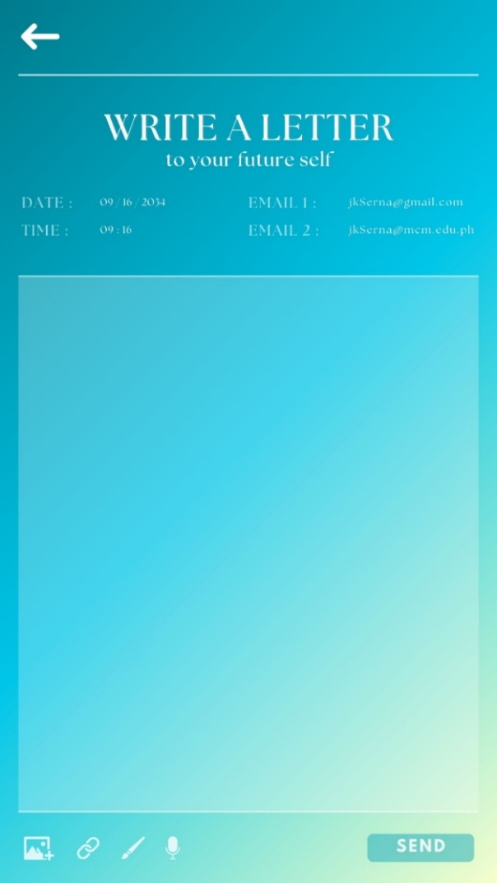**<-Time Capsule** The Time Capsule page lets the user write a letter to their future self. Users can choose a date and time for when they want the letter to be sent. The letter will be sent to the registered email of the account, but the user can also add another email in case of any future problems. Users can upload photos and videos, links, voice recordings, and even create paintings.

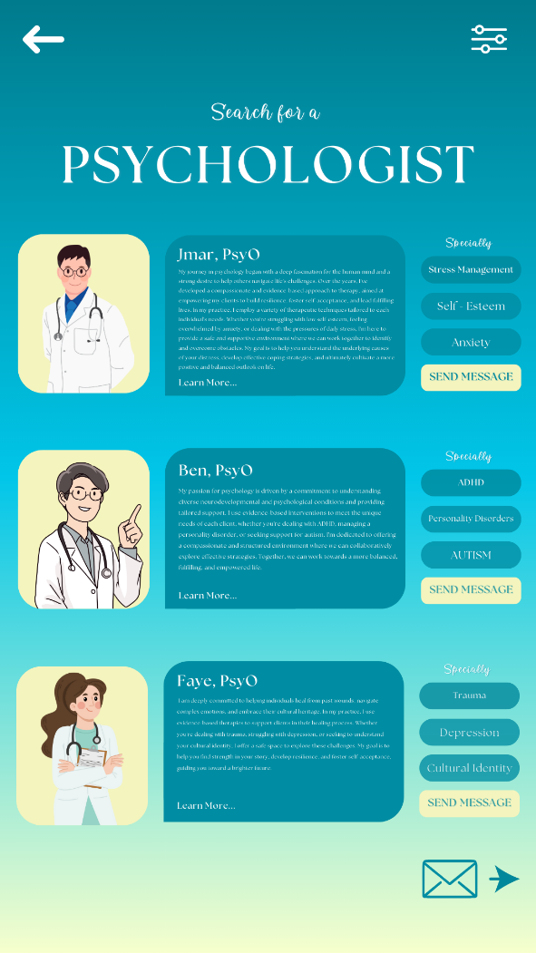 **Teletherapy->**

The Teletherapy page enables users to find and connect with a psychologist for consulting. Users can view detailed profiles of available psychologists, including their specialties and therapeutic approaches. Each profile includes an option to send a direct message for consultation. The page is designed to help users find the right psychologist for their specific needs, whether it be stress management, self-esteem issues, anxiety, ADHD, personality disorders, autism, trauma, depression, or cultural identity concerns.

Initial Evaluation Plan

The team has chosen to base our usability criteria on the study by Jander et al. (2011). These criteria are divided into five main categories: Efficiency, Relevance, Learnability & Memorability, User Errors, and Attitude. This framework will allow us to evaluate whether our system design improves the ease and convenience of using our app compared to other mental health support methods.

For evaluation, we will conduct a survey using forms designed to assess the app's design based on the adopted usability criteria. A 5-point Likert Scale, with 5 as the highest and 1 as the lowest, will measure the success of each indicator. We will calculate the average responses for each criterion as a percentage to evaluate the effectiveness of every aspect of our system.

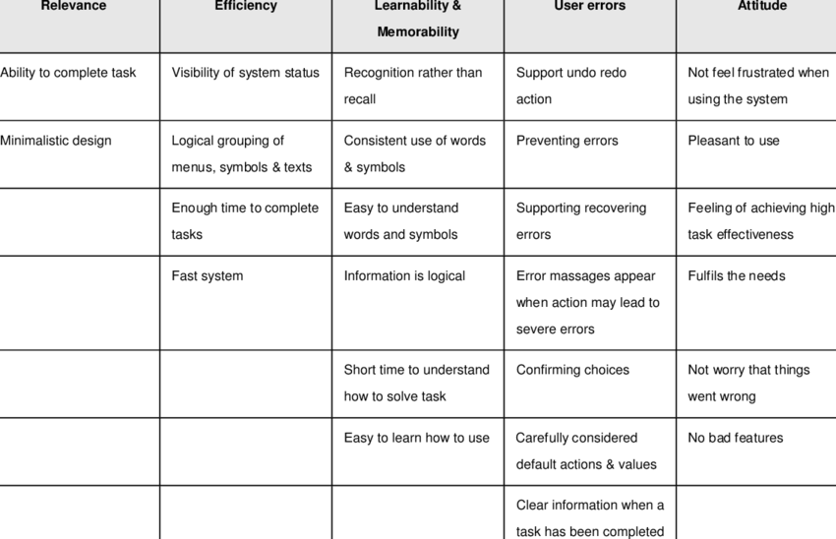

After designing the prototypes, the designers decided to simplify the main page by displaying the mental health metrics and the list of goals directly on the main page instead of on separate pages. This decision was made to motivate users by allowing them to see their progress and goals immediately upon logging in and opening the app. By consolidating these elements on the main page, users can quickly access important information, fostering a sense of accomplishment and encouraging continued engagement with the app.

Reference: Jander, H., Borgvall, J, & Castor, M. (2011). Brain Budget. Evaluation of Human Machine Interaction in System Development for High Risk and Task Critical Environments. Researchgate. Retrieved from: https://www.researchgate.net/figure/Usability-criteria-classified-under-the-five-maincategories-Efficiency-Relevance_tbl2_280943018